**OPS102 – Week 4 – File Systems - Sample Lab**

Student Name: Abcedi Ilacas

Student ID: 138180211

**Activity 1: Redirection and Piping**

Put following text to a file called gpt.txt

ChatGPT is an artificial intelligence chatbot developed by OpenAI and released in November 2022.

The name "ChatGPT" combines "Chat", referring to its chatbot functionality, and "GPT", which stands for Generative Pre-trained Transformer, a type of large language model.

Wikipedia

ChatGPT has been trained on huge amount of data scraped from internet.

This has enabled us to develop artificial programs that can answer questions like humans.

**Redirection:**

Redirection can send input to a command from a file or can send output of a command to a file.

Input redirection symbol: <

**Command < filename**

1. Run the command on Linux: **cat < gpt.txt**

What do you see and why?

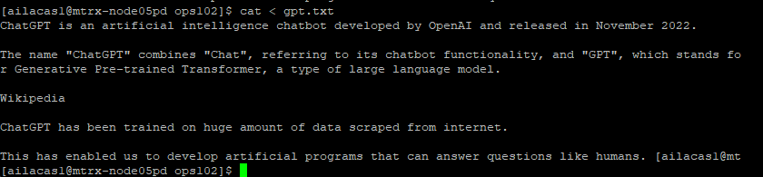

The contents of gpt.txt since the cat command reads the file and outputs it.

1. Run similar command on Windows: **TYPE < gpt.txt**

What do you see and why?

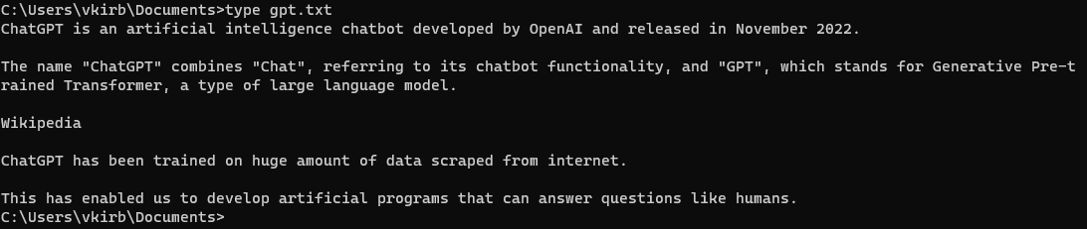

The same as the cat command in linux, the type command displays the file contents.

Output redirection symbol: >

**Command > filename**

1. Run the command on Linux **ls -l > list.txt**

What is the output? Explain

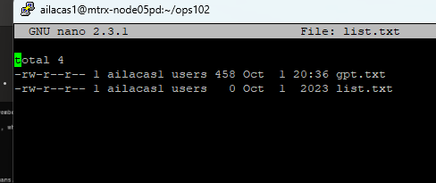

This command lists all of the contents in the current directory with detailed info of each file like permissions and file types and then redirects the output into a file list.txt.

1. Run equivalent command on Windows: **dir > list.txt**

What is the output? Explain

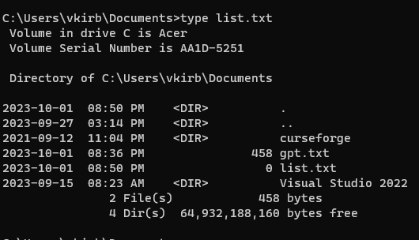

Equivalent to ls –l > list.txt. Listed all files and redirects output to a file list.txt.

1. Run the command on both Linux and Windows: **sort < list.txt**

What is the output?

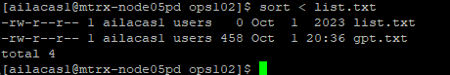

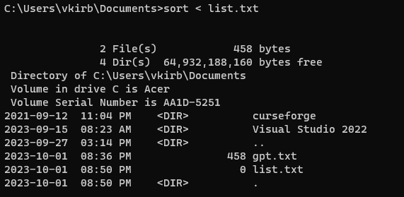

This sorts the contents of list.txt alphabetically and displays it to the terminal.l

**Piping:**

**Command1 | Command2**

Piping is used to redirect output of first command to the input of the second command. This allows to combine simple commands to achieve more complex task.

Perform following tasks and add screenshots

1. On Linux run the command **ls /bin | more**

What do you see and why?

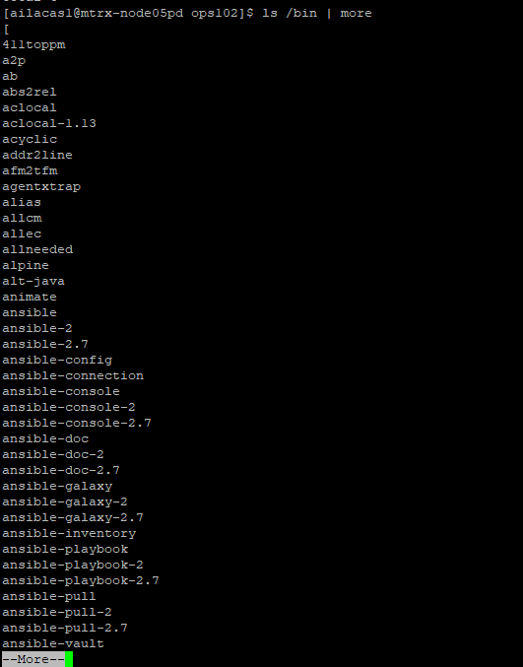

This command lists the files in the /bin directory and uses more to display the output one screen at a time.

1. Suppose you have a text file called gpt.txt having following text in it

On Windows run the command **TYPE gpt.txt | FIND “GPT”**

What is the output? Explain it:



Searches for the string “GPT” in gpt.txt and outputs all the lines in the file with the specified string. In this case, every line in the file had the specified string so it displayed all lines.

(TYPE is equivalent to cat command on Linux)

1. Run and explain the command: **cat < gpt.txt | sort > out.txt**

Explain what is happening in above command?



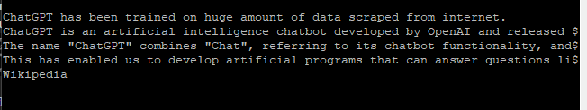

This command reads gpt.txt, sorts its contents and outputs the sorted contents to file out.txt.

**Activity 2: File Permissions**

Consider following image for next tasks

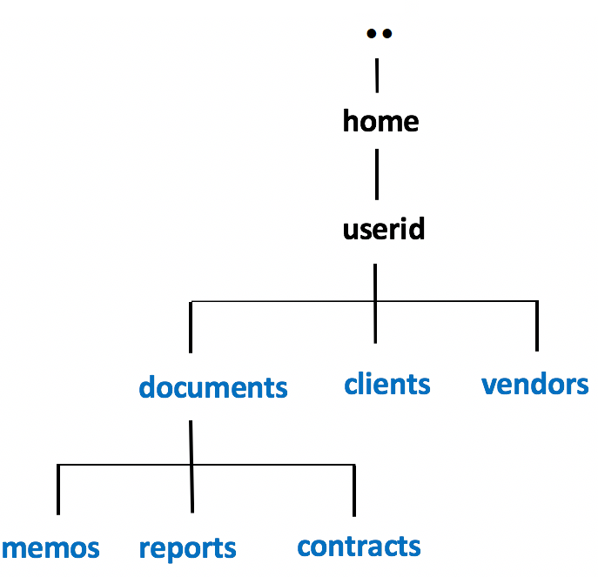

Choose any way to create following files in the respective folders

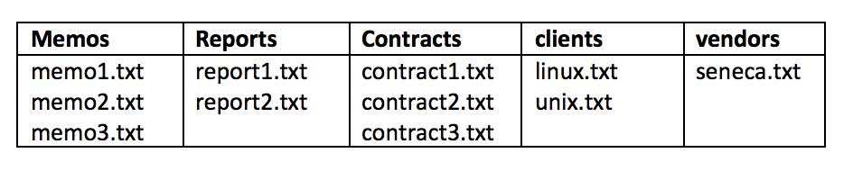

1. Issue the following Linux commands:  
   **ls -ld ~/documents ~/clients ~/vendors**  
   **ls -lR ~/documents ~/clients ~/vendors**  
   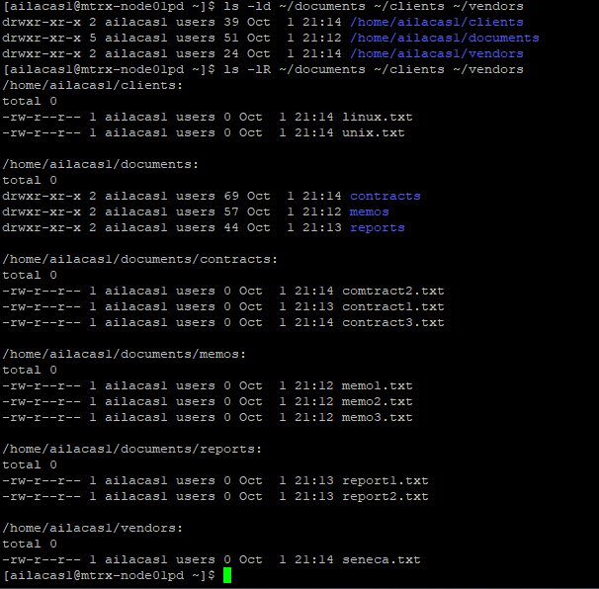
2. Let's limit access to the **clients** and **vendors** directories to only yourself and same group members.  
   Issue the following Linux command:  
   **chmod 750 ~/clients ~/vendors**

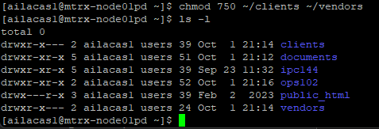

1. Issue the **ls -ld** and **ls -lR** commands (as you did in *step #8*) to confirm that the permissions for those directories have been changed.  
     
   **NOTE:** The **-R** option for the **chmod** command can change the file permissions recursively within a directory structure.

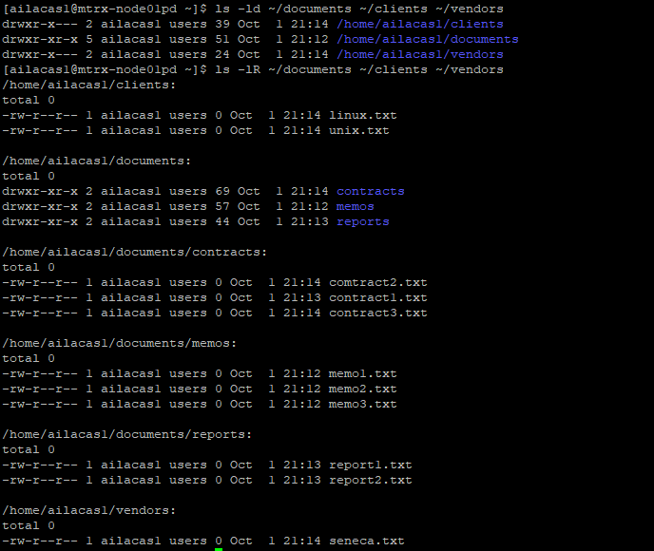

1. Issue the following Linux command: **chmod 750 -R ~/documents**



1. Issue the **ls -ld** command to confirm the permissions for the  
   **~/documents**, **~/document/memos** , **~/documents/reports**, and **~/documents/contracts** directories.

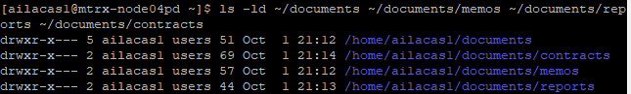

1. Issue the following Linux command: **ls -lR ~/documents**  
   What do you noticed happened to the permissions for the regular files contained in those directories.  
   Did those regular file permissions change?

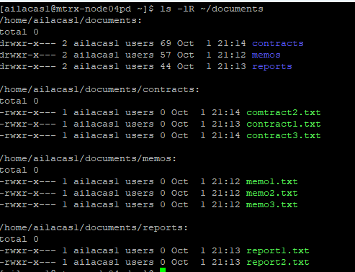

After the chmod command, the files have read, write, and execute permissions for the owner, and read and execute permissions for the group, with no permissions for others.  
  
 We will now change permissions for regular text file contained in subdirectories  
 of the **documents** directory to: **r w - r - - - - -**

1. Issue the following Linux commands:   
   **chmod 640 ~/documents/memos/memo*.txt**  
   **chmod 640 ~/documents/reports/report*.txt**  
   **chmod 640 ~/documents/contracts/contract*.txt**



1. Issue the **ls -lR** command for the **~/documents** directory to confirm that those regular file permissions have changed.

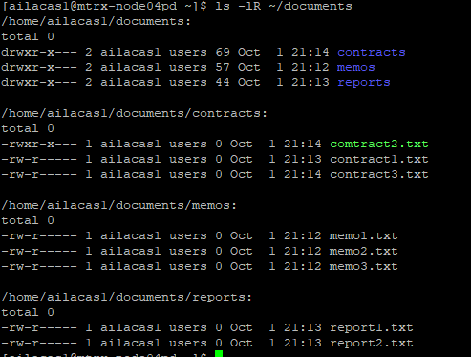

1. Issue the following Linux command to add write permissions for all files in the memos directory  
   for yourself (i.e. user): **chmod u+w ~/documents/memos/\***

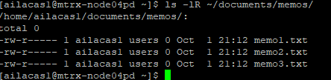

Instructor Note: Use Windows Properties to show how to change file permissions